EENG 385 - Electronic Devices and Circuits

Frequency Domain: Active Filters

How To: Build a Bode Plot Using Point-by-Point Method

**How to: Audio Board, Bode Plot via Point by Point**

You will now draw the Bode plots of the filters using the test and measurement equipment to determine the magnitude and phase change of a low pass filter using the same point-by-point methods you used in MultiSim Live. While there are a lot of instructions, once you have everything properly setup, this process goes quick. In other words, don’t be intimidated by the length of the instructions.

**Step 1: Setup the function generator:**

The first step in measuring your filter behavior is to properly setup the function generator output. If you do this step improperly, then you may damage the op amp in your audio board. This will result in you wasting time yours’s and the TA’s time troubleshooting your Audio board. A little extra time here is good insurance.

The procedure to setup the function generator is given in list below. Each step is lettered A…K to correspond to letters in Figure 1.

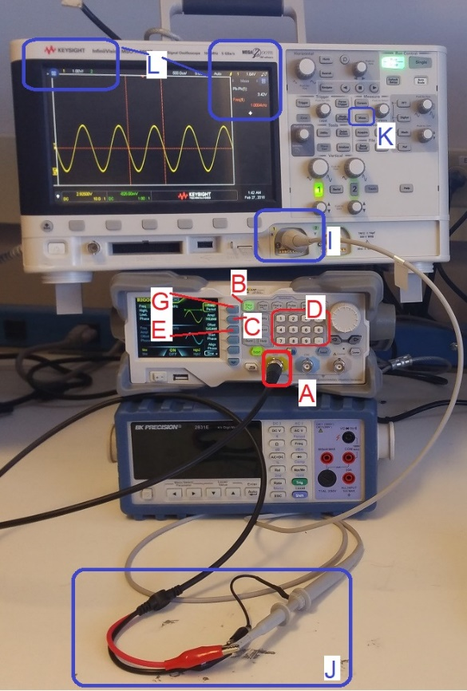

Figure 1: The test and measurement setup to check the signal input. Please DO NOT stack the equipment as pictured – this was done to fit all the equipment in one picture.

In the following procedure, dedicated keys are denoted with bold text in square brackets. Softkey are shown highlighted.

1. Connect a proper signal generator cable to the yellow BNC connector labeled "CH1" on the Rigol DG1022Z function generator. Insert firmly and twist until you feel it click. Give it a tug to make sure the BNC connector is securely mated,
2. If the **[Sine]** function key is not illuminated, press to illuminate it,
3. Press the Ampl/HiLevel softkey to highlight "HiLevel",
4. Enter 3.0 on the numeric keypad, and then press the Vpp softkey
5. Press the Offset/LoLevel softkey to highlight “LoLevel,
6. Enter 0 on the numeric keypad, and then press the Vpp softkey
7. Press the Freq/Period softkey to highlight “Freq”,
8. Enter 2.0 on the numeric keypad, and then press the kHz softkey
9. Connect a proper oscilloscope probe to the channel 1 input of the oscilloscope. Adjust the vertical scale to 1V/div and the horizontal scale to 500us, make sure that channel 1 is DC coupled, and that the trigger level is around 2.5V,
10. Connect the function generator and oscilloscope cables, black clip to black clip and red clip to scope probe,
11. Adjust the scopes so that they display frequency and the peak-to-peak amplitude of the waveform.
    * **[Meas]** → Clear Meas → Clear All
    * **[Meas]** → Source → 1
    * **[Meas]** → Type → Peak-Peak → Add Measurement
    * **[Meas]** → Type → Freq
    * **[↑ Back]**

Once complete, you should see the audio waveform on the oscilloscope oscillating between the ground reference and 5V. Only when you are sure that your function generator is setup correctly should you move to the next step.

**Step 2: Apply signal to the filter and measure input/output**

You are now going to use the function generator to send sin waves with varying frequencies into the LPF input and measure the amplitude and phase shift of the output waveform.

* Install female end of a male/female jumper wire onto the INPUT LPF pin,
* Install female end of a male/female jumper wire onto the OUTPUT LPF pin,
* Turn the function generator off by pressing the **[OUTPUT]** key,
* Attach the black ground clip of the function generator to a ground loop on the Audio board,
* Attach the black ground clip of the oscilloscope probe to a ground loop on the Audio board,
* Configure your oscilloscope,

|  |  |
| --- | --- |
| Horizontal (scale) | 1ms |
| Ch1 probe | INPUT LPF (male end of jumper wire) |
| Ch1 (scale) | 2V/div |
| Ch1 (coupling) | DC |
| Ch2 probe | OUTPUT LPF (male end of jumper wire) |
| Ch2 (scale) | 2V/div |
| Ch2 (coupling) | DC |
| Trigger source | 1 |
| Trigger slope | ↑ |
| Trigger level | 2.5V |

* Configure your oscilloscope to measure to the attenuation and phase shift of the filter,
  + [Meas] → Type → Phase
  + [Meas] → Setting → Source1: 2
  + [Meas] → Setting → Source2: 1
  + [Meas] → Add Measurement
  + [Meas] → Type → Ratio - Full Screen
  + [Meas] → Add Measurement
  + **[↑ Back]**
* Attach the red signal clip of the function generator to male end of jumper wire attached to the INPUT LPF jumper wire,
* Verify that everything is setup correctly by comparing your setup to Figure 2,

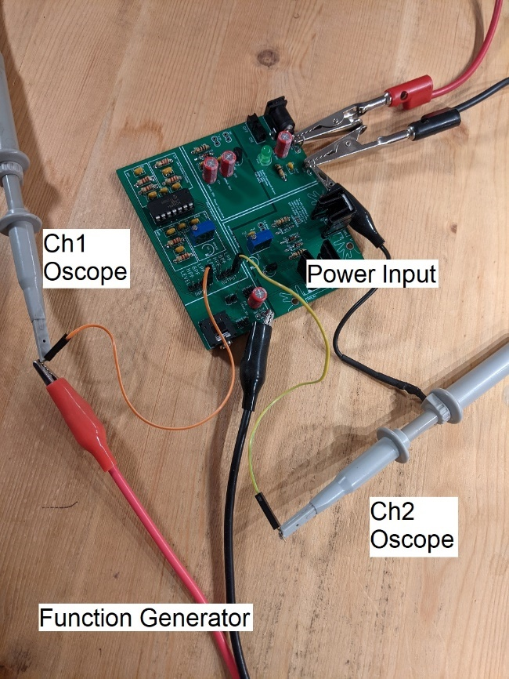

Figure 2: The setup to apply a signal to the LPF and measure the response on the oscilloscope.

* Enable the function generator output
* Observe the oscilloscope, it should look something like Figure 3.

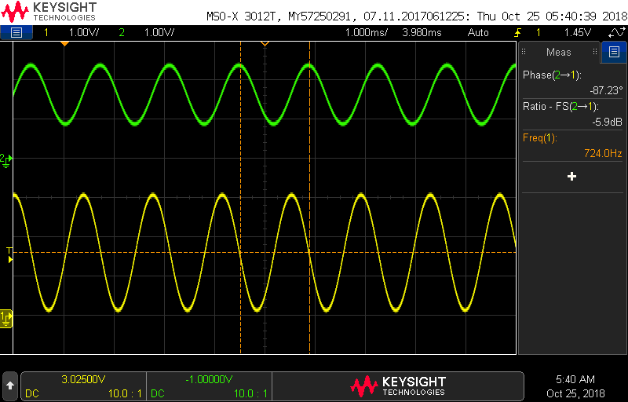

Figure 3: The input and output of the low-pass filter.

Now you are ready to collect the data to draw your Bode plot for the low-pass filter. Open the filterBehaviorWorksheet you downloaded earlier in the lab and select the LPFexp tab. Set the function generator to each frequency listed in column B and record the attenuation and phase measured by the oscilloscope into the respective columns. As you add these data values, the Bode plots will automatically graph this data.

Before jumping in and measuring all the values, please take a few moments to read over the following list of points; it will save you from having to repeat measurements.

* If a cell in the Freq column does not have an entry, find the frequency (by adjusting the function generator) that generates the gain or phase listed in that row.
* At low frequencies, the Gain and Phase measurements will not be reliably reported by the oscilloscope. Please just use the default values provided in the Excel file.
* The oscilloscopes will display phase values in the range [180° to -180°]. You should plot your phase delay over the range [0° to -360°]. Thus, if the oscilloscope displays a phase of 170°, correct this by subtracting 360° yielding (a mathematically equivalent) -190°.
* As you increase the input frequency to around 10kHz, it will become very difficult to measure the magnitude and phase of the output waveform. When this happens, make the following modification to the oscilloscope:
  + Switch channel 2 into AC coupling, by pressing the channel 2 button and select Coupling: AC. Move the channel 2 ground reference to the middle of the upper half of the display,
  + Use the acquire function to average together several channel 2 waveforms. **[Acquire]** → AcqMode → Averaging → #Avgs: 128. You will notice that the waveform updates occur much more slowly and morph whenever you change the frequency. However, you will be able to measure incredibly small amplitudes (down to about -60dB) in this mode,
* You will see the gain of the Bode plot start to rise at the high frequencies. This is a result of the fact that our circuit has a non-zero amount of inductance For more information check out [EEVblog #859 - Bypass Capacitor Tutorial](https://www.youtube.com/watch?v=BcJ6UdDx1vg) and jump to 11:44.

To save the image on the screen

* + [Save/Recall] → Save → Format → 24-bit Bitmap image (*.bmp)
  + [Save/Recall] → Save → Press to Save